**CDAC Mumbai PG-DAC AUGUST 24**

**Assignment No- 2**

1)Write a program that checks if a given year is a leap year or not using both if-else and switch-case.

import java.util.*;

import java.lang.*;

public class leap{

public static void main(String[] args){

Scanner sc=new Scanner(System.in);

System.out.print("Enter year: ");

int year=sc.nextInt();

int r=((year%400==0)||((year%4==0)&&(year%100!=0)))?1:0;

switch(r){

    case 1:

    System.out.print("leap year");

    break;

case 0:

System.out.print("not a leap year");

break;}

    }

}

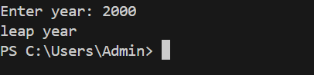

2)Implement a program that calculates the Body Mass Index (BMI) based on height and weight input using if-else to classify the BMI int categories (underweight, normal weight, overweight,etc).

import java.util.*;

import java.lang.*;

public class Bmi{

    public static void main(String[] args){

Scanner sc= new Scanner(System.in);

System.out.print("Enter height in m: ");

double ht= sc.nextDouble();

System.out.print("nter weight in kg: ");

double wt=sc.nextDouble();

double bmi=wt/Math.pow(ht,2);

System.out.println("bmi is: "+String.format("%.3f",bmi));

if(bmi<18){

    System.out.println("underweight");

}

else if(bmi>=18 && bmi<=25){

    System.out.println("normal weight");

}

else {System.out.println("overweight");}

    }

}

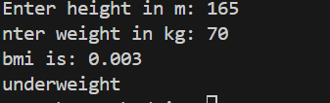

3)Write a program that checks if a person is eligible to vote based on their age.

import java.util.*;

public class age{

public static void main(String[] args){

Scanner sc=new Scanner(System.in);

System.out.print("Enter Age: ");

int age=sc.nextInt();

if(age>=18){

    System.out.print("Eligible");

}

else if(age<0){

System.out.print("Enter Valid Age");

}

else{System.out.print("Not Eligible");}

    }

}

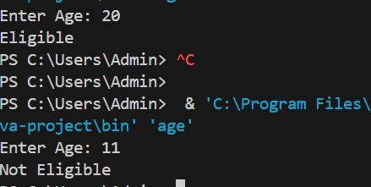

4)Write a program that takes a month (1-12) and prints the corresponding season (Winter, Spring, Summer, Autumn) using a switch case

import java.util.*;

public class season{

public static void main(String[] args){

Scanner sc=new Scanner(System.in);

System.out.print("Enter Month: ");

int month=sc.nextInt();

switch(month){

case 1:{

    System.out.print("Winter");

    break;

}

case 2:

case 3:System.out.print("Spring");

    break;

case 4:

case 5:

case 6:

case 7:

case 8:

System.out.print("Summer");

break;

case 9:

case 10:

System.out.print("Autumn");

break;

case 11:

case 12:

System.out.print("Winter");

    break;

}

    }

}

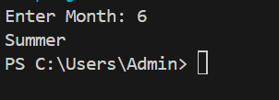

5)Write a program that allows the user to select a shape (Circle, Square, Rectangle, Triangle) and then calculates the area based on user-provided dimensions using a switch case.

import java.util.*;

import java.lang.*;

public class shape{

public static void main(String[] args){

Scanner sc=new Scanner(System.in);

String[] a1={"Circle","circle"};

String[] a2={"Square" ,"square"};

String[] a3={"Rectangle","rectangle"};

String[] a4={"Triangle","triangle"};

  System.out.print("Enter a Shape (Circle, Square, Rectangle, Triangle): ");

String s=sc.next().trim().toLowerCase();

switch(s){

case "circle":{

final double Pi=3.14159265;

System.out.print("Enter Radius: ");

double radius=sc.nextDouble();

double area=Pi*Math.pow(radius,2);

System.out.print("Area of Circle is= "+String.format("%.3f",area));

break;}

case "square":{

System.out.print("Enter side length: ");

double side=sc.nextDouble();

double area=Math.pow(side,2);

System.out.print("Area of square is= "+String.format("%.3f",area));

break;}

case "rectangle":{

System.out.print("Enter length: ");

double l=sc.nextDouble();

System.out.print("enter width: ");

double b=sc.nextDouble();

double area=l*b;

System.out.print("area of rectangle is= "+String.format("%.3f",area));

break;}

case "triangle":{

System.out.print("enter b: ");

double b=sc.nextDouble();

System.out.print("enter h: ");

double h=sc.nextDouble();

double area=(0.5*b*h);

System.out.print("area of triangle is= "+String.format("%.3f",area));

break;}

}

    }

}

